 Snapchat

**Snapchat**: Empowering Real-Time Communication and Creative Expression

Founded by Evan Spiegel, Bobby Murphy, and Reggie Brown in 2011, Snapchat has emerged as a groundbreaking social media platform, transforming how people communicate, share moments, and express themselves in a digital age. With its unique focus on ephemeral content and innovative features, Snapchat has garnered a global user base, redefining social interactions in a visually engaging manner.

**Product Dissection and Real-World Problems Solved by Snapchat:**

Snapchat, a global phenomenon, effectively addresses real-world challenges by offering innovative solutions:

* **Real-Time Connection**: In an era where communication often feels asynchronous, Snapchat enables real-time interactions. Users can send photos and videos as "Snaps" that disappear after being viewed, promoting authentic and immediate connections.
* **Privacy Concerns**: Privacy issues in social media are prevalent. Snapchat acknowledges the importance of user privacy by making Snaps temporary and notifying users when someone takes a screenshot. This approach addresses concerns about data permanence.
* **Creative Expression**: The platform encourages creative expression through features like Filters, Lenses, and Bitmojis. It provides tools for users to add a personal touch to their Snaps, solving the challenge of creative limitation.
* **Storytelling**: Snapchat Stories allow users to create a narrative with their Snaps, sharing moments of their day with followers. This feature provides a solution to the desire for a more coherent and chronological way of sharing experiences.

**Case Study: Real-World Problems and Snapchat's Innovative Solutions**

**Problem 1:** **Real-Time Connection**

**Real-World Challenge**: Online interactions can lack the immediacy and authenticity of in-person communication.

Snapchat's Solution: By introducing Snaps with limited viewing time, Snapchat brings real-time engagement to the digital realm. Users can send Snaps as if they were having a face-to-face conversation, with content disappearing after being viewed. This approach bridges the gap between online and offline communication.

**Problem 2**: **Privacy Concerns**

Real-World Challenge: Users often worry about the permanence of content and data shared online.

Snapchat's Solution: Snapchat addresses privacy concerns by making Snaps temporary. Once a Snap is viewed, it disappears, and users are notified of any screenshot attempts. This approach empowers users to share without the fear of data being stored indefinitely.

**Problem 3: Creative Expression**

Real-World Challenge: Users seek ways to infuse creativity into their digital communications.

Snapchat's Solution: Snapchat offers a plethora of creative tools, including Filters, Lenses, and Bitmojis. These features allow users to add unique and playful elements to their Snaps, satisfying the desire for creative expression.

**Problem 4: Storytelling**

Real-World Challenge: Sharing fragmented moments online can be disjointed and lack narrative structure.

Snapchat's Solution: Snapchat Stories enable users to curate a chronological sequence of Snaps, providing a solution for storytelling. Users can share a cohesive narrative of their day, enhancing the sharing of experiences.

**Top Features of Snapchat:**

* **Snaps**: Users can send photos and videos as Snaps, which disappear after being viewed, fostering real-time interactions.
* **Stories**: Snapchat Stories allow users to compile Snaps into a chronological narrative, enhancing storytelling.
* **Filters and Lenses**: Creative tools to add fun and personal touches to Snaps, promoting creative expression.
* **Chat**: Real-time text, voice, and video chat features that facilitate immediate and meaningful connections.
* **Discover**: A section for curated content, including news, entertainment, and original shows.
* **Snap Map**: Location-sharing feature for users to see their friends' real-time locations on a map.
* **Memories**: A feature to save and share favorite Snaps and Stories, addressing the issue of content permanence.

Snapchat's design and features successfully tackle real-world challenges by offering a platform for authentic, creative, and real-time interactions, making it a pioneering player in the realm of social media.

This case study provides an overview of how Snapchat has innovatively addressed real-world challenges, much like the Instagram case study you requested earlier. Snapchat's features have revolutionized the way users communicate and express themselves in the digital landscape.

**Entity Relationship**

The ER diagram for Snapchat might include entities like Users, Snaps, Stories, Chat Conversations, Discover Content, Filters, and Lenses, with attributes and relationships defined for each. This visual representation can help you and others understand the data architecture that underpins Snapchat's functionality.

Schema Description for Snapchat

The schema for Snapchat comprises various entities that represent different aspects of the platform. These entities include Users, Snaps, Stories, Chat Conversations, Discover Content, Filters, and Lenses, each with specific attributes and relationships with other entities.

**User Entity**: Users are central to Snapchat, and the user entity contains information about each user:

* UserID (Primary Key): A unique identifier for each user.
* Username: The chosen username for the user's account.
* Email: The user's email address for account-related communication.
* Full_Name: The user's full name as displayed on their profile.
* Bitmoji: A personalized avatar that represents the user.
* Registration_Date: The date when the user joined Snapchat.

**Snap Entity**: Snaps are at the core of Snapchat and capture visual and time-limited content:

* SnapID (Primary Key): A unique identifier for each snap.
* UserID (Foreign Key referencing User Entity): The user who created the snap.
* Media_URL: The URL of the image or video content.
* Duration: The time duration for which the snap is viewable.
* Snap_Date: The date and time when the snap was created.

**Story Entity**: Stories allow users to share content that can be viewed by their friends for a longer duration:

* StoryID (Primary Key): A unique identifier for each story.
* UserID (Foreign Key referencing User Entity): The user who created the story.
* Media_URL: The URL of the image or video content in the story.
* Duration: The time duration for which the story is viewable.
* Story_Date: The date and time when the story was created.

**Chat Conversation Entity**: Chat conversations facilitate one-on-one and group communication on Snapchat:

* ChatID (Primary Key): A unique identifier for each chat conversation.
* Participant_1_UserID (Foreign Key referencing User Entity): User ID of the first participant.
* Participant_2_UserID (Foreign Key referencing User Entity): User ID of the second participant.
* Group_Chat: A boolean attribute indicating if the chat is a group chat.
* Last_Message_Date: The date and time of the last message in the chat.

**Discover Content Entity**: Discover content includes articles and videos from publishers and creators:

* DiscoverID (Primary Key): A unique identifier for each Discover content.
* Title: The title of the Discover article or video.
* Content_URL: The URL to access the Discover content.
* Publisher: The publisher or creator of the content.
* Publish_Date: The date the Discover content was published.

**Filter Entity**: Filters are graphical overlays that users can add to their snaps:

* FilterID (Primary Key): A unique identifier for each filter.
* Name: The name or description of the filter.
* Image_URL: The URL of the filter's graphical overlay.
* Category: The category or type of filter.

**Lens Entity**: Lenses are augmented reality effects that users can apply to their snaps:

* LensID (Primary Key): A unique identifier for each lens.
* Name: The name or description of the lens.
* Lens_URL: The URL to access the lens's augmented reality effects.
* Category: The category or type of lens.

**Relationships**:

* Users send Snaps and Stories – Each user can create multiple snaps and stories.
* Users engage in Chat Conversations – Users participate in multiple chat conversations.
* Users discover Discover Content – Users can access various pieces of Discover content.
* Users use Filters – Users can apply different filters to their snaps.
* Users apply Lenses – Users can use various lenses for augmented reality effects.

This schema description outlines the key entities, attributes, and relationships within Snapchat's data structure, providing a foundational understanding of how Snapchat organizes and manages its data.

+-------------------+

| Snapchat |

+-------------------+

| 1

|

|

|

|

|

+-------------------+

| Users |

+-------------------+

| - UserID (PK) |

| - Username |

| - Email |

| - Full_Name |

| - Bitmoji |

| - Registration_Date |

+------------------------+

1 | 1

|

1 |

+-------------------+

| Snaps |

+-------------------+

| - SnapID (PK) |

| - UserID (FK) |

| - Media_URL |

| - Duration |

| - Snap_Date |

+-------------------+

1 | 1

|

1 |

+-------------------+

| Stories |

+-------------------+

| - StoryID (PK) |

| - UserID (FK) |

| - Media_URL |

| - Duration |

| - Story_Date |

+-------------------+

|

|

|

+-------------------+

| Chat Conversations |

+-------------------+

| - ChatID (PK) |

| - Participant_1_UserID (FK) |

| - Participant_2_UserID (FK) |

| - Group_Chat |

| - Last_Message_Date |

+----------------------------------+

1| 1

|

|

|

+-------------------+

| Discover Content |

+-------------------+

| - DiscoverID (PK) |

| - Title |

| - Content_URL |

| - Publisher |

| - Publish_Date |

+-------------------+

1 | 1

|

1 |

+-------------------+

| Filters |

+-------------------+

| - FilterID (PK) |

| - Name |

| - Image_URL |

| - Category |

+-------------------+

1 | 1

|

|

1 |

+-------------------+

| Lenses |

+-------------------+

| - LensID (PK) |

| - Name |

| - Lens_URL |

| - Category |

+-------------------+

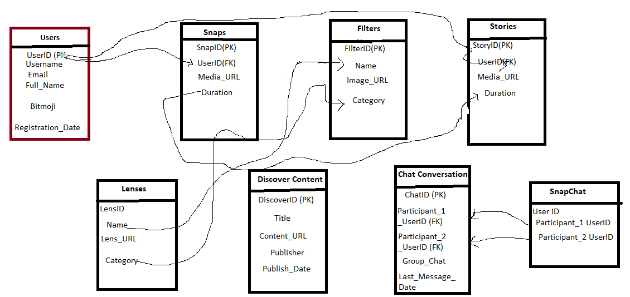

**ER-Diagram of Snapchat**

In this simplified ER diagram:

* Users can send Snaps and Stories.
* Users engage in Chat Conversations.
* Users can access Discover Content.
* Users can apply Filters and Lenses to their Snaps.
* Various entities have relationships with the User entity, which represents the core of Snapchat.

Snapchat's data model is more complex in reality, and there would be many more attributes and relationships to represent the platform's features fully. This simplified diagram provides a high-level view of the main entities and their relationships.

**Conclusion**

In this case study, we have explored the design and innovative features of Snapchat's schema and Entity-Relationship diagram. Snapchat has redefined the way people communicate, express themselves, and share moments, addressing various real-world challenges in the digital age.

The platform's intricate data model, featuring entities like Snaps, Stories, Filters, and real-time interactions, forms the foundation for its unique functionality. Snapchat has effectively tackled significant real-world problems, offering solutions that have contributed to its widespread popularity and continuous growth in the realm of social media.

Snapchat's commitment to real-time connections, user privacy, creative expression, and storytelling has made it a pioneering player in the world of social media. Through ephemeral content, creative tools, and features that bridge the gap between digital interactions and real emotions, Snapchat has successfully fostered genuine connections and addressed contemporary challenges in the digital landscape.

Snapchat has reimagined how people interact and share their lives, making it a standout platform for authentic, creative, and real-time communication.